* 1. Was it difficult to record your dietary intake for the two days? Why or why not?

No, using online services makes access to the site easy and quick.

* 1. Identify and discuss why you believe specific areas were positive or negative. What influences you to eat specific foods?

Not only my overall health depends on my diet and exercise but also the extent of my efforts to push back CMT is dependent on my choice of food. Keeping a regular journal is important as it allows better analysis. The ritual of entering data in the journal also reaffirms one’s commitment and helps to stay focused. I have to also guard against falling behind on my projects for work or school. Working late to catch-up almost always leads o stressful feelings, consumption of caffeine and anything that the vending machine has to offer.

* 1. Was anything surprising in regard to your dietary analysis? Why or why not?

I have been doing this for a long time now but I remember in the beginning I was always surprised how quickly the number of calories increased when you moved out of your target category. For example if your normal sank s baby carrots increasing the number of snakes does not change your overall profile my much. But changing it from baby carrots to M&Ms has a dramatic effect on the final outputs.

* 1. As a result of this dietary analysis, what **specific** recommendations do you have regarding your current eating habits? Provide at least 3 recommendations and briefly justify each. How do you plan on achieving these recommendations?

My dietary plan coincides with my fitness plan. My overall aim is to lose ~2 lb/week going forward for the next 123 months. Increasing my plant based consumption of calories and reducing animal based calories guaranties a more stable and diverse source of nutrients.

1. Preparing and proportioning food for the whole week eliminates all the guess work.
2. Logging the ingredients keeps me motivated by insuring that I am on track.
3. Consuming only what I cook at home eliminates the lack of good options when eating out.
   1. Do you think that this assignment will cause you to make **real** changes in your eating habits? Why or why not?

Yes, back when I replaced whole eggs with egg whites my one week report confirmed that I was maintaining my desired protein intake while drastically reducing cholesterol. Or when I started adding kale to my yogurt the amount of my mineral intake dramatically increases. Seeing clear indicators like this are great influences to recognizing and eventually eliminating bad habits as well as following up on and increasing the frequency of good habits.

# Nutrients Report for the past 4 weeks:

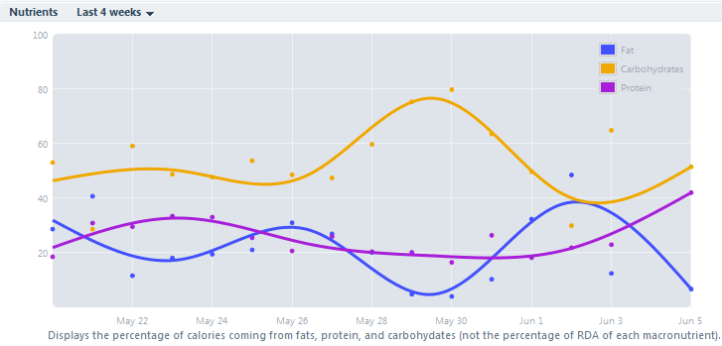

# Meal Summary for the past 4 weeks: